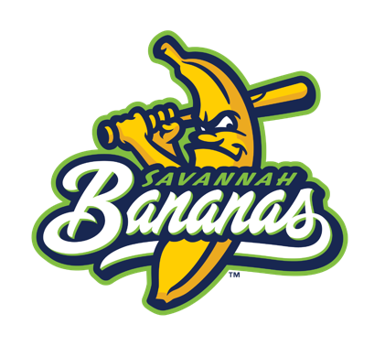
Camp FAQ’s
*The Priority List will be able to register for camps starting Wednesday, January 18th at 9am, with them going live to the public on Friday, January 20th*

Types of Camps: One Day, Two Day, Four Day

Camp Dates:
One Day: February 12, February 26th, March 12th, April 16th, May 14th, July 9th, July 18th, August 6th, September 3rd
Two Day: September 23rd & 24th
Four Day: June 6th-9th, June 13th-16th, August 1st-4th

What time is camp?
- One and two day camps will run from 1:00 to 5:00pm, with registration starting 30 minutes before the start of camp.
- Four day camp will run from 9:00am to 12:00pm, with registration starting 30 minutes before the start of camp.

Where is registration at?
- At the front gate at the front of the stadium.

Can parents stay and watch?
- Yes, parents are encouraged to sit anywhere in the stadium and join in on all the fun, or simply just drop off and pick up.

What does my camper need to bring?
- All of the baseball or softball equipment you have, we also have bats and gloves that we can lend out for the entirety of camp.

What should my camper wear to camp?
- While your typical baseball uniform and pants will do just fine, we encourage all of our campers to show up in crazy costumes, hats, and anything else they can think of since we will be giving out best dressed awards!

Are girls allowed at camp?
- Yes!

My camper has food allergies, what do I need to do?
- No food will be given out at camp. We ask that parents list the camper’s allergies (if any) when initially registering for camp.

Where is camp held?
- Here at Grayson Stadium, 1401 E Victory Drive Savannah, GA!

Will the merchandise stand be open?
- Yes, one day during each camp!

What age camper can come?
- Kids ages 6-13!

